A

TECHNICAL REPORT ON

STUDENTS INDUSTRIAL WORK EXPERIENCE SCHEME (SIWES)

AT

NEOCLOUD TECHNOLOGIES | ICT | COMPUTER TRAINING IN ABUJA.

PRESENTED BY

CHUKWU DANIEL NONSO

BHU/20/04/05/0010.

SUBMITTED TO

THE DEPARTMENT OF COMPUTER SCIENCE,

FACULTY OF SCIENCE AND TECHNOLOGY,

BINGHAM UNIVERSITY KARU, NASSARAWA STATE, NIGERIA.

IN PARTIAL FULFILMENT OF THE REQUIREMENTS FOR THE AWARD OF BACHELOR OF SCIENCE (B.Sc.) DEGREE IN COMPUTER SCIENCE.

OCTOBER, 2023.

# 

# CERTIFICATION

This is to certify that this report represents the students’ industrial work experience at Neo Cloud Technologies | ICT | Computer Training in Abuja | Suite C30 & 31, M.I.B Plaza, 1st Avenue, Gwarinpa, Nigeria.

I hereby certify that **CHUKWU DANIEL NONSO** with matriculation number **BHU/20/04/05/0010** of the Computer Science department of Bingham University, Karu, Nasarawa state, wrote this report in partial fulfillment of the requirements for the award of Bachelor of Science (B.Sc.).

This report has not been submitted elsewhere.

NAME OF H.O.D NAME OF SIWES CORDINATOR

**DR ADAMU USMAN DR ADELAIYE ISHAYA**

SIGNATURE & DATE SIGNATURE & DATE

____________________ ____________________

NAME OF INSTITUTE BASED SUPERVISOR

……………………………

SIGNATURE & DATE

____________________

# DEDICATION

# This report is a heartfelt tribute to the remarkable individuals whose unwavering support and guidance significantly contributed to my personal and professional growth during my attachment period at Neo Cloud Technologies in Gwarinpa, Abuja.

# My deep gratitude extends not only to my mentors and colleagues but also to my parents, whose invaluable support and encouragement made this entire program possible. Their steadfast belief in my journey and their unwavering support sustained me throughout the program, and for that, I am forever grateful.

# ACKNOWLEDGEMENT

I extend my heartfelt gratitude to Almighty God and the myriad of individuals who have contributed in diverse ways to the successful completion of my industrial training at Neo Cloud Technologies. I am deeply thankful to the organization for affording me the invaluable opportunity to partake in this significant phase of my education and professional development.

I also wish to express my appreciation to all those who played pivotal roles in ensuring the success of my Industrial Training, including my fellow trainees, whose camaraderie added a special dimension to my journey.

A special mention of thanks goes to my dedicated SIWES coordinator, Dr. Adelaiye Ishaya, as well as the esteemed Head of the Department of Computer Science, Dr. Adamu Usman, and faculty members such as Mrs. Ann Hassan, Dr. Silas Faki, Dr. Egene Onu, Dr. Felix, Dr. Gaga, Mr. Godwin Elekwa, Mr. Yusuf Musa, Mr. Jenom Maikori, Mr. Barka Fori, Mr. Langthon, Mr. Joseph Aremu, and Mrs. Ipole Nancy. Your guidance and support were invaluable.

My gratitude extends to the departmental secretary, Mrs. Talatu Bowman, and all the dedicated staff members of Bingham University who have contributed to my academic journey.

This successful completion of my industrial training would not have been possible without the collective efforts, support, and guidance of these remarkable individuals and institutions. I am truly grateful for the opportunity and the knowledge gained during this phase of my education.

A very special thanks also goes out to my parents, whose selfless sacrifices have been the bedrock of my endeavors. Their unwavering support is a driving force behind my success, and I am committed to honoring their sacrifices by striving for excellence in all that I do.

**CHUKWU DANIEL NONSO**

# ABSTRACT

The Student Industrial Work Experience Scheme established by the Federal Government of Nigeria was aimed at exposing students of higher institutions to acquire industrial skills and practical experiences in their approved courses of study and also prepare students for the Industrial work situation which they are likely to meet after graduation. This technical report is based on the experiences gained during my Seven months of Industrial Training at Neo Cloud Technologies. This report highlights the major based technologies used in the company and projects I was able to gain first-hand experience working on.

Contents

CERTIFICATION 2

DEDICATION 3

ACKNOWLEDGEMENT  4

ABSTRACT 5

CHAPTER ONE 8

1.1 INTRODUCTION TO THE SIWES PROGRAM 8

1.2 HISTORY OF THE SIWES PROGRAM 8

1.2 NATURE AND SCOPE OF SIWES 9

1.3 AIMS AND OBJECTIVES OF SIWES 9

1.4 SIWES BENEFITS 10

CHAPTER TWO 12

2.1 DESCRIPTION OF THE ORGANIZATION 12

2.2 WHY WE EXIST 12

2.3 MISSION 12

2.4 BIG-PICTURE VISSION 13

2.5 BRAND STORY 13

2.6 SERVICES 13

2.7 MEMBERS OF THE ORGANIZATION 16

2.8 COMPANY’S OPERATION 17

2.9 COMPANIES POLICIES 18

CHAPTER THREE 21

3.1 INDUSTRIAL WORK 21

3.2 PORTFOLIO WEBSITE 21

3.3 TAKE NOTE (A NOTE TAKING APPLICATION) 23

3.4 NEO CLOUD TECHNOLOGIES MOBILE APP 25

CHAPTER FOUR 32

4.1 SUMMARY  32

4.2 SIWES CHALLENGES AND RECOMMENDATIONS 32

4.3 CONCLUSION 34

4.4 REFERENCES 35

­

# CHAPTER ONE

**INTRODUCTION**

## 1.1 INTRODUCTION TO THE SIWES PROGRAM

## Prior to the inception of the Student Industrial Work Experience Scheme (SIWES), a growing concern prevailed among industrialists regarding the readiness of graduates from higher education institutions. They believed that these graduates lacked the necessary practical background essential for employment in various industries. Consequently, employers held the view that the theoretical education provided by higher institutions did not align with the practical requirements of the labour market.

## In response to this pressing issue, the Industrial Training Fund (ITF) took a proactive step by establishing the Student Industrial Work Experience Scheme (SIWES) in 1973. SIWES emerged as a mandatory Skills Training Programme aimed at addressing the deficiency in practical skills among Nigerian graduates from tertiary institutions. Its primary objective was to bridge the gap between theoretical knowledge and the practical competencies necessary for successful employment within the industrial sector.

## 1.2 HISTORY OF THE SIWES PROGRAM

In 1973, The Industrial Training Fund (I.T.F) established the SIWES program. In 1974, it was officially presented and approved by the Federal government. However, the ITF withdrew from the program due to financial constraints in 1978. So in 1979, the National Universities Commission (NUC) and the National Board for Technical Education (NBTE) took over the management of the program.

In November 1984, from the federal government, the management and implementation of SIWES were handed back to ITF. In July 1985, ITF officially took charge of the scheme while the federal government took care of the funds.

Before the scheme was established, Nigerian industrialists expressed concerns that graduates lacked proper practical skills for employment in industries.

Furthermore, the theoretical aspects of education in universities didn’t match the requirements of employers in the labour market. So the industrialists called for the creation of a program that would allow students to garner the required practical skills they’d need to increase their chances of getting employed.

## 1.3 NATURE AND SCOPE OF SIWES

The duration of a student's attachment during SIWES varies depending on the specific program. Typically, the minimum duration for SIWES should be six months or twenty-four week. Throughout the course of the program, students are expected to accumulate a total attachment duration of at least 240 hours on a full-time basis, which may occur during either term-time or extended vacation periods.

In addition to the attachment period, there are induction sessions conducted by teaching departments. These sessions serve to impart essential concepts related to key skills, workplace safety, professional expectations, legalities, and ethics. These sessions are crucial in preparing students for their SIWES experience, equipping them with the necessary knowledge and skills for learning, employment, and life.

1.4 AIMS AND OBJECTIVES OF SIWES

Participation in SIWES has become a mandatory requirement for obtaining Diploma and Degree certificates in specific fields at the majority of higher education institutions in the country, in strict accordance with the government's educational policy.

It aims to:

1. Equip students with the necessary skills and acumen to navigate the demands of the industrial workplace post-graduation.
2. Familiarize students with specialized work methods and advanced equipment not typically available within their academic institutions.
3. Facilitate a smoother transition from academic life to the professional world, enhancing their network for future job opportunities.
4. Bridge the gap between theoretical knowledge and practical application by allowing students to apply their learning in real-world scenarios.
5. Foster and strengthen collaboration with employers throughout the educational journey, ultimately preparing students for successful employment upon graduation.

## 1.5 SIWES BENEFITS

Experts recognize that industrial experience is essential for effective job preparation. This is because experience significantly enhances the productivity of both recent graduates and newcomers entering the workforce. Early exposure to the industry's values and skills is crucial. Without the right skills and experiences, young graduates are not adequately equipped with the necessary work-related norms and behaviours, which are vital for success in the workplace.

Today, the landscape of many jobs is being reshaped by Information and Communication Technology (ICT), resulting in shifts in the knowledge and skills required of workers. Consequently, our students need to attain a new level of competency that goes beyond what traditional educational facilities can provide. This necessitates a collaborative effort between educational institutions and the industrial sector.

One of the primary advantages for students who actively participate in industrial training lies in the skills and competencies they acquire. These skills, often referred to as Relevant Production Skills (RPSs), become lifelong assets. They are internalized during training and prove invaluable when students apply them to perform their jobs or functions. Additionally, numerous other benefits accrue to students who engage in industrial training.

Furthermore, industrial training provides a conducive environment for students to develop and enhance personal attributes such as critical thinking, creativity, initiative, resourcefulness, leadership, time management, presentation skills, and interpersonal skills, among others. These attributes are invaluable assets that can significantly enrich a student's overall skill set and readiness for the professional world.

# CHAPTER TWO

**THE ORGANIZATION /INDUSTRY**

2.1 DESCRIPTION OF THE ORGANIZATION

Neo Cloud Technologies is a multi-product IT firm that provides creative and technology services across various sectors.

In the fall of 2017, Neo Cloud recognized a need in the industry for an innovative IT consulting firm that prioritized the needs of their clients. They’ve since then expanded to a team of over 25 employees, all of whom are dedicated to implementing full-stack solutions for Digital Transformation.

Neo Cloud also largely focuses on the education aspect of tech, training students all across the globe that are looking to get into tech. The company has trained over 2000 Nigerians in areas such as Cloud computing, Web development, Backend Development, Graphics Design, Data Analysis and so on.

Neo Cloud Technologies has over 20 certified instructors that are highly skilled at training people and taking their various skill levels from beginner to expert.

2.2 WHY WE EXIST

We exist as an IT company to forge innovative solutions that will change the narrative of the information technology ecosystem through the creation of bespoke solutions that meet customers' needs.

2.3 MISSION

To constantly exceed customer expectations by understanding their business needs and providing complete IT solutions.

2.4 BIG-PICTURE VISSION

Neo Cloud Technologies belongs to a specialised niche or business, yet it is far from alone. With the appropriate innovation, we will be able to give something unique to our customers, making their brand stand out in the market and making it extremely easy for them to grow their income.

Talented, forward-thinking individuals want to work with forward-thinking organizations. Because the firm has a history of innovation, Neo Cloud Technologies is designed to attract anyone who is going to build the next great thing. We foster and develop innovators because they want to be challenged and pushed to innovate on a regular basis.

2.5 BRAND STORY

Neo Cloud Technologies was founded in November 2017, with the mission of constantly exceeding customer expectations by understanding their business needs and providing complete solutions. The company has always positioned itself as a provider of bespoke solutions to client's needs in the technology space.

The brand message "The Hybrid Experience" refers to a complete new technology experience created by combining clients' obsolete technology with our emerging technology and bespoke solutions to meet their everyday needs as an organization or individual. Regardless of their location, we have them covered because we are "The Hybrid Experience."

2.6 SERVICES

The company provides the critical combination of infrastructure, service, training, and management required to unleash the power of ICT and Trans-National Education (TNE), leading to globally recognized degree and certifications for human capacity development and economic empowerment

The company provides educational facilities and learning guideline and also gets contracted by both governmental and non-governmental organizations to help build software’s and network for their organization.

Some services provided includes:

**IT Support Services**

We provide a wide range of IT Services, including Onsite and Remote Support, IT Consultancy, System Maintenance, Software Installation, Cybersecurity Services, Networking Support, Web and Application Development, Virus Protection, Backup and Recovery, Camera Setups and More

**Software Project Rescue**

Clients who are experiencing difficulties with ongoing software projects or who need maintenance for existing applications can turn to Neo Cloud Technologies for assistance

**Software Development**

Neo Cloud Technologies has reputable proficiency in the development of Custom Software Solutions, Portals, e-Commerce Applications, Business Application and Automation Software

**IT Product Sales**

With a dedicated design desk team created as part of our Managed Service Program, our Hardware and Software Design Specialists know how to maximize vendor programs to ensure that our clients maximize their technology expenditures

**Cyber Security Services**

At Neo Cloud, we offer top-tier Cybersecurity Solutions that protect your Digital Assets, thereby ensuring business continuity and boosting client’s confidence. We identify potential cyber hazards to your organization and implement stringent preventative measures

**Cloud Solutions**

Your company will be able to adapt more quickly to shifting market dynamics if you take advantage of the complete Cloud Solutions that we provide here at Neo Cloud. These Solutions improve flexibility, cut expenses, and increase operational efficiency.

**Data Science Services**

We specialize in Artificial Intelligence, Data Science, and Big Data Analytics. Neo Cloud helps its customers increase productivity, return on investment, and strategic decision-making by empowering them to create data-driven companies. When you work with us, you will have access to industry-leading Analytics Measures for your business

**Corporate Branding Services**

Create an identity for your business or modernize an outdated appearance to make it more visually appealing for your brand. We create unique, ready-to-go designs for your company, ranging from Logo, Website Design, Packaging to Custom illustrations

**Digital Marketing Services**

You can no longer expect to win clients over by depending solely on your traditional advertising strategies given the growing number of businesses that are devoting more time and resources to Online Marketing. Internet marketing services that are focused on providing value can help you boost your sales volume while also laying a solid basis for your business's digital presence

**Social Media Services**

The Neo Cloud Social Media Brand Management Solution integrates Social Media Management and Social Media Advertising to help Businesses create a strong and consistent online presence that draws in new customers, keeps existing ones engaged, and increases sales and profits

**SEO Services**

To get your website to the top of Google's search results page, you need a collaborator who is well-versed in Search Engine Optimization (SEO). To assist you climb the search engine rankings, we provide top-tier Search Engine Optimization (SEO) Services

**IT Staffing Services**

We provide our clients with a comprehensive selection of IT Staffing options, which includes Contract Workers, Contract-to-Hire Placements, Direct Hiring, and a Managed Service

2.6 MEMBERS OF THE ORGANIZATION

 



**Anthony Ojei Sharon Omolegbe Jerry Brown**

Head - Digital Marketing Manager Head - Visual Communications





**Brown George Godstime Edet**

Head – Training & Research Head – Software Engineering

2.7 COMPANY’S OPERATION

Neo Cloud Technology plays a very vital role in the community with standard educational systems, solution to all kinds of problems, and a great facility for all. I actually chose this company because they had great facilities for self-development, with great people there and they didn’t seem too stiff as most government agencies are.

The company's daily operations involve a dual focus on student training and project development for external organizations, with working hours from 8 am to 4 pm. Training for students are scheduled on Mondays, Wednesdays, and Fridays, while Tuesdays and Thursdays are dedicated to self-development. At the company, we highly encouraged and sponsored employees to enhance their knowledge and skills, fostering continuous growth.

The training program encompasses a wide array of courses, each conducted in separate classrooms by various instructors, who may deliver the lessons either virtually or in person at the organization. This approach allows the company to offer a diverse range of educational opportunities, ensuring that the students receive comprehensive training tailored to their specific needs.

Additionally, during the summer months, we held a special boot camp for children aged 6 to 18. This program aimed at enriching kids understanding of technology and equipped them with valuable computer skills. They engaged in various courses, including web development, graphic designing, Microsoft tool usage, typing lessons, coding, and design, as well as other essential computer skills. Our goal was to inspire and empower the next generation of tech-savvy younglings, setting them on a path to success in the digital age.

2.8 COMPANIES POLICIES

The company has established a set of rules and policies to govern its operations. These policies ensure a smooth and ethical working environment for all staff members.

1. **Confidentiality Policy:**

* Protect sensitive company information and client data.
* Do not disclose proprietary information to external parties without proper authorization.
* Diversity and Inclusion Policy:

1. **Promote diversity and inclusivity in all aspects of the workplace.**

* Respect and value differences among colleagues and clients.

1. **Health and Safety Policy:**

* Prioritize the health and safety of all employees.
* Follow safety guidelines and report any hazards or incidents promptly.

1. **Professional Development Policy:**

* Continuously improve your skills and knowledge.
* Utilize available resources for self-improvement and career growth.

1. **Anti-Harassment Policy:**

* Create a respectful and harassment-free workplace.
* Report any instances of harassment, discrimination, or misconduct immediately.

1. **Social Media and Online Conduct Policy:**

* Maintain a professional online presence.
* Do not engage in any behavior online that reflects negatively on the company.

1. **Environmental Sustainability Policy:**

* Contribute to environmental conservation efforts.
* Reduce waste and promote eco-friendly practices in the workplace.

1. **Expense Reimbursement Policy:**

* Adhere to company guidelines for expense reporting and reimbursement.
* Ensure all expenses are legitimate and properly documented.

1. **Code of Ethics and Integrity:**

* Uphold high ethical standards in all business dealings.
* Avoid conflicts of interest and act honestly and transparently.

1. **Data Security and Privacy Policy:**

* Safeguard sensitive data and personal information.
* Comply with data protection regulations and company data security protocols.

1. **Dress Code and Appearance Policy:**

* Adhere to the company's dress code guidelines.
* Present a professional and neat appearance at all times.

1. **Customer Satisfaction Policy:**

* Prioritize customer satisfaction in all interactions.
* Go the extra mile to meet customer needs and expectations.

These policies reflects the company’s commitment to professionalism, ethics, and the well-being of our employees and clients. Violations of these policies may result in appropriate consequences, as the company places a strong emphasis on upholding its rules and standards.

# CHAPTER THREE

**SIWES ACTIVITIES**

3.1 INDUSTRIAL WORK

During my 7 months of Internship experience at Neo Cloud Technologies, I was able to learn a lot of new things and gain a first-hand experience on how a real world tech job would be like.

I worked mainly with the cross platform mobile app building tech stack called Flutter as that was the technology I was required to work with mainly at the company. But even though I worked with Flutter mainly, I was able to also cut across an array of equally interesting technologies and ended up building some simple applications, such as:

* My Portfolio Website
* A Note Taking Application
* A School Management System Mobile App (Still in development…)

3.2 PORTFOLIO WEBSITE

I was able to rebuild my portfolio website using Next.JS, Framer Motion and Tailwind CSS. I got the chance to learn all these technologies during my time at the company. Some of the features I was able to implement in this portfolio are as follows

* Smooth navbar selection (using framer motion)
* Page Reveal (using framer motion)
* Light and Dark Mode (using TailwindCSS)
* Messaging (using Twillio)
* State Management (using Zustland)

I got to deploy the application on vercel and got a free domain as you can tell from the domain name with the .vercel.app extention

**Link:** <https://chukwudaniel.vercel.app/>

**Old Portfolio Link:** <https://chukwudaniel.netlify.app/>

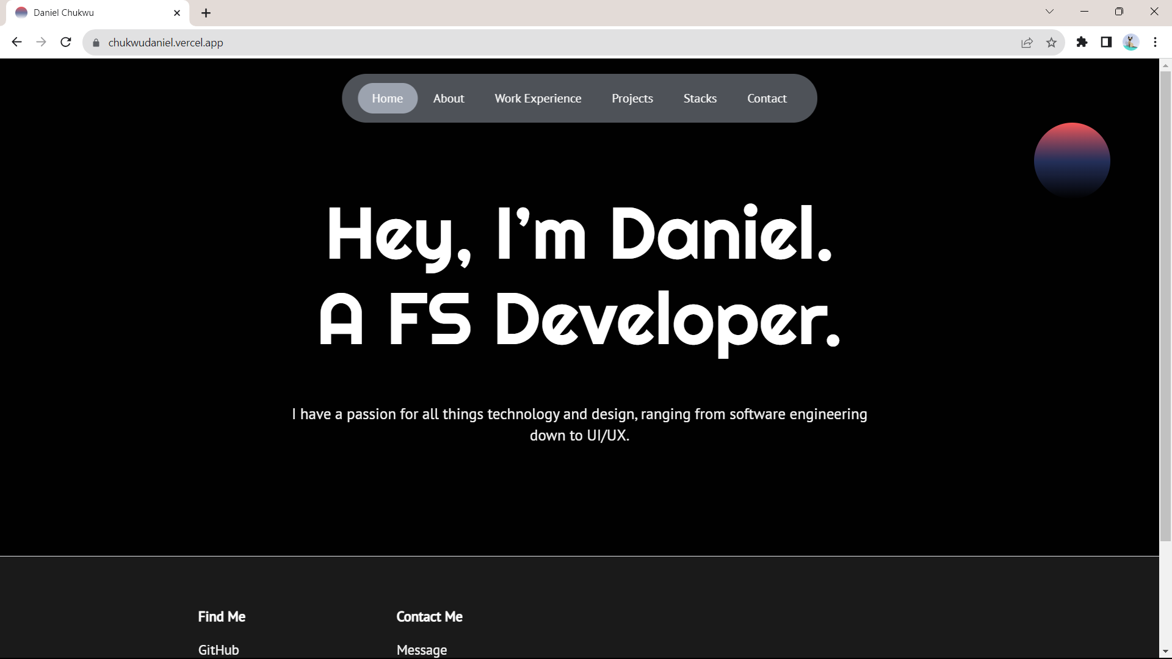

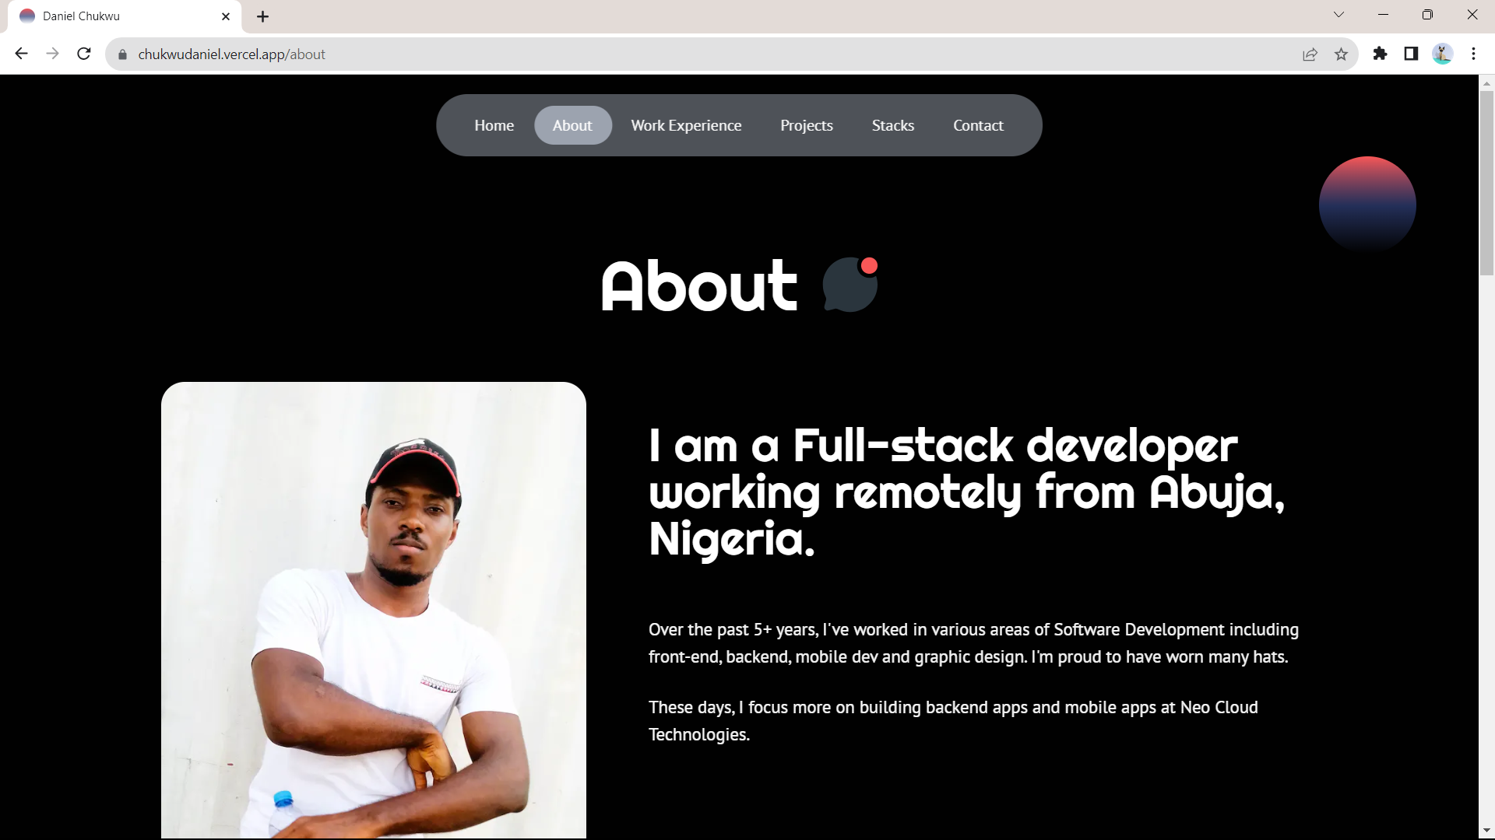

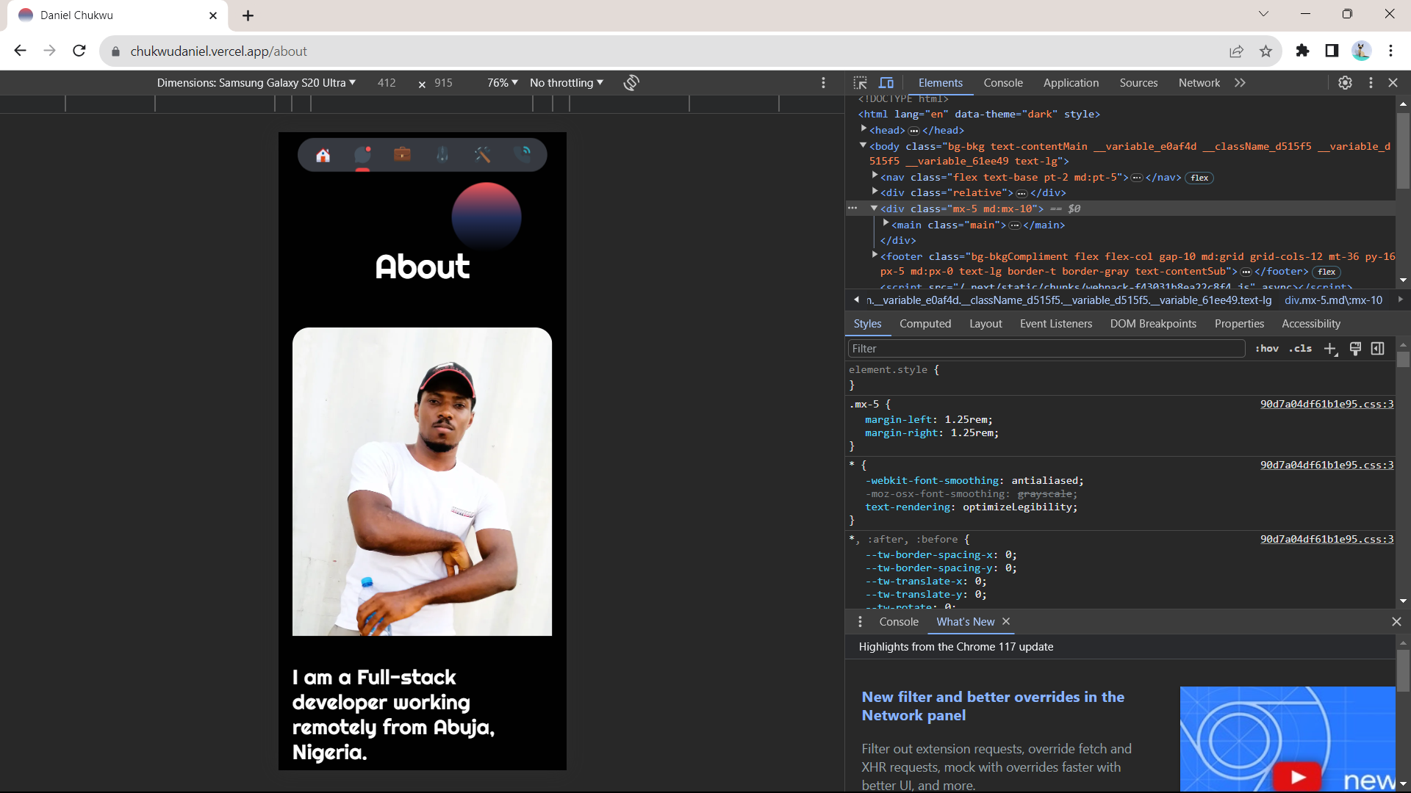

3.3 TAKE NOTE (A NOTE TAKING APPLICATION)

I always wanted to create an application that had a different feel to note taking, I was able to achieve this during the SIWES program. Unlike the portfolio website, this note taking application required a backend and a database to store the notes taken. The application was built using Typescript and Angular JS for the frontend and Spring Boot with Java for the backend, while I used PostgreSQL for the database.

This application took a month to complete and it had the following features.

* Authentication
* Notebook
* Note Taking (in NoteBooks)
* And CRUD operations for Notebooks and the notes in those notebooks

I deployed both the frontend and backend of this application on render.com

**Link:** <https://takenote-h0yd.onrender.com/>

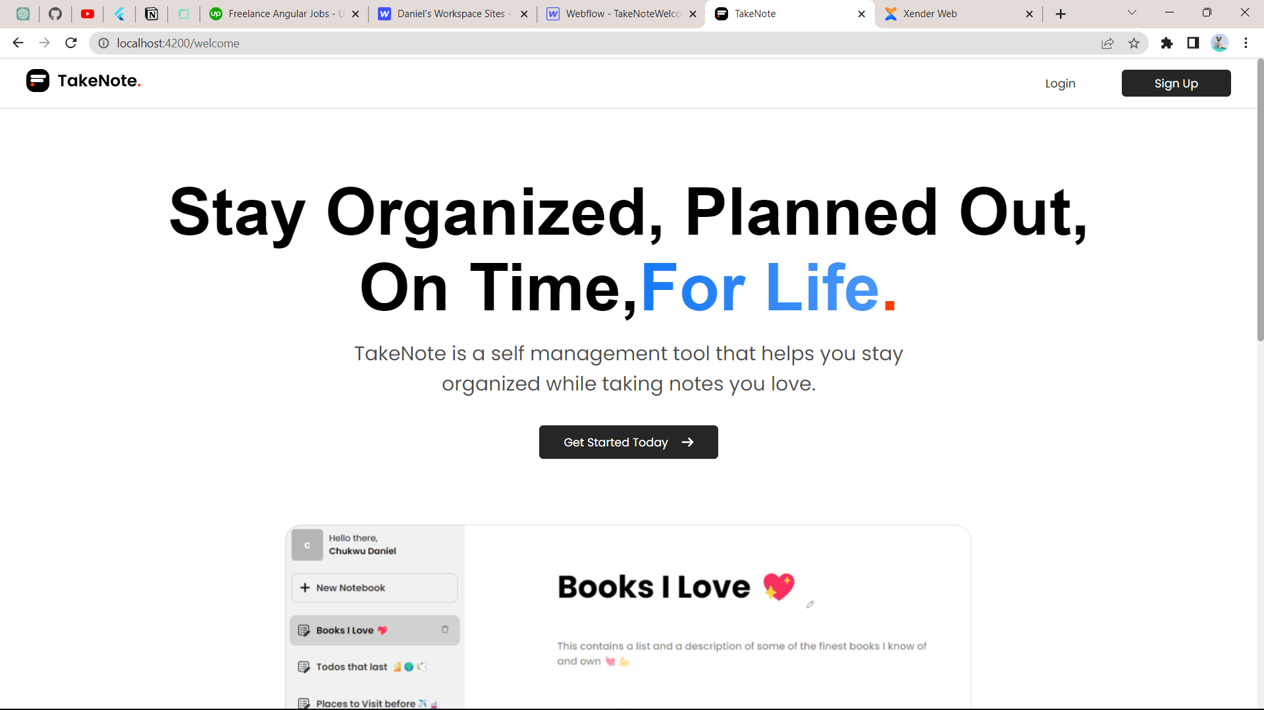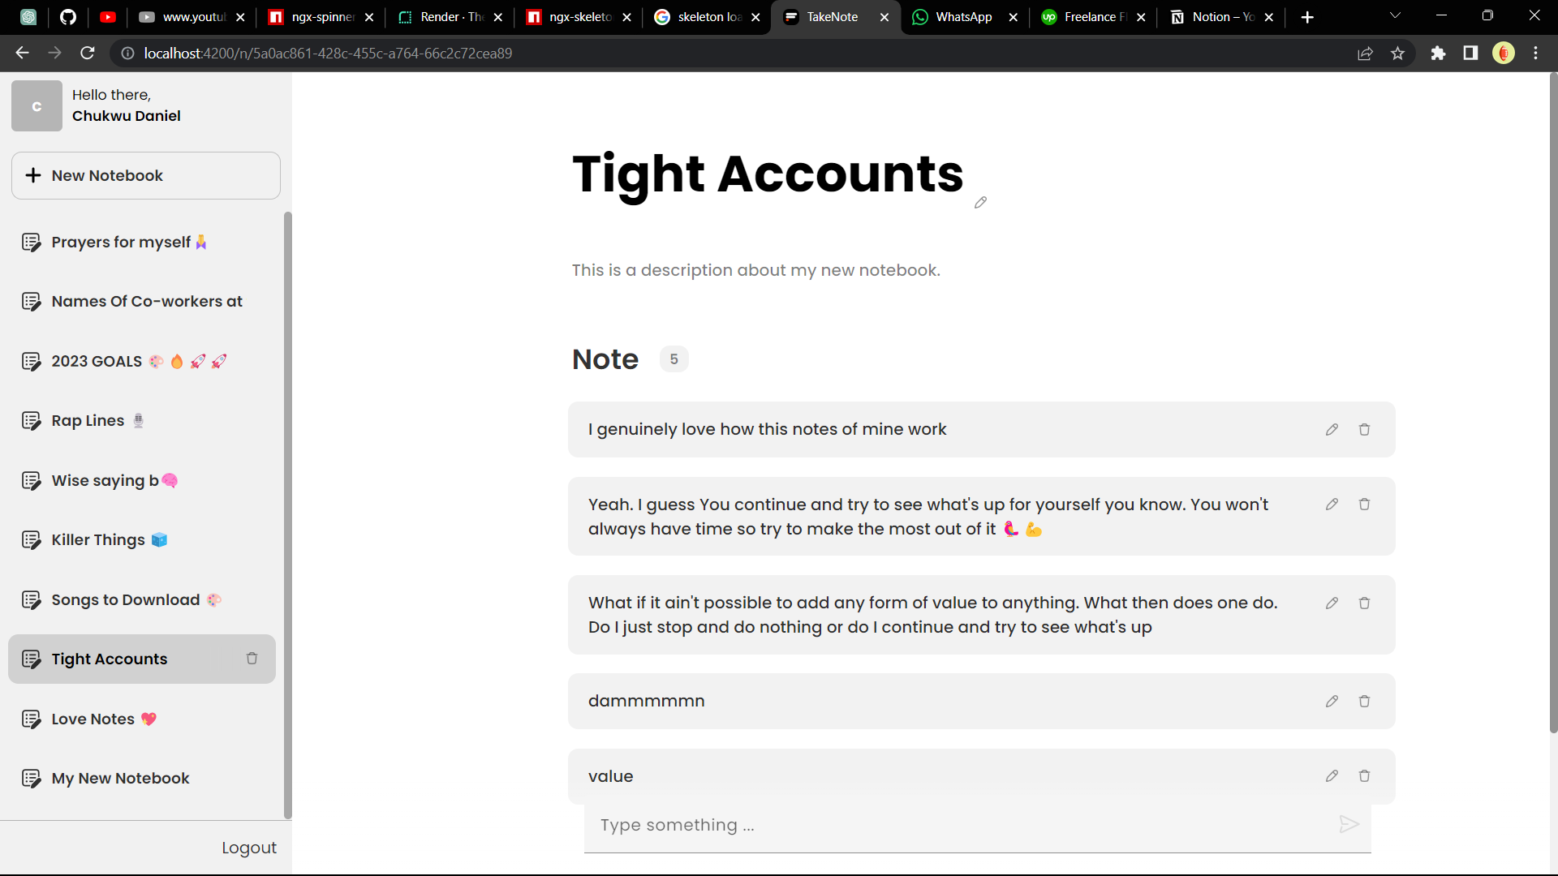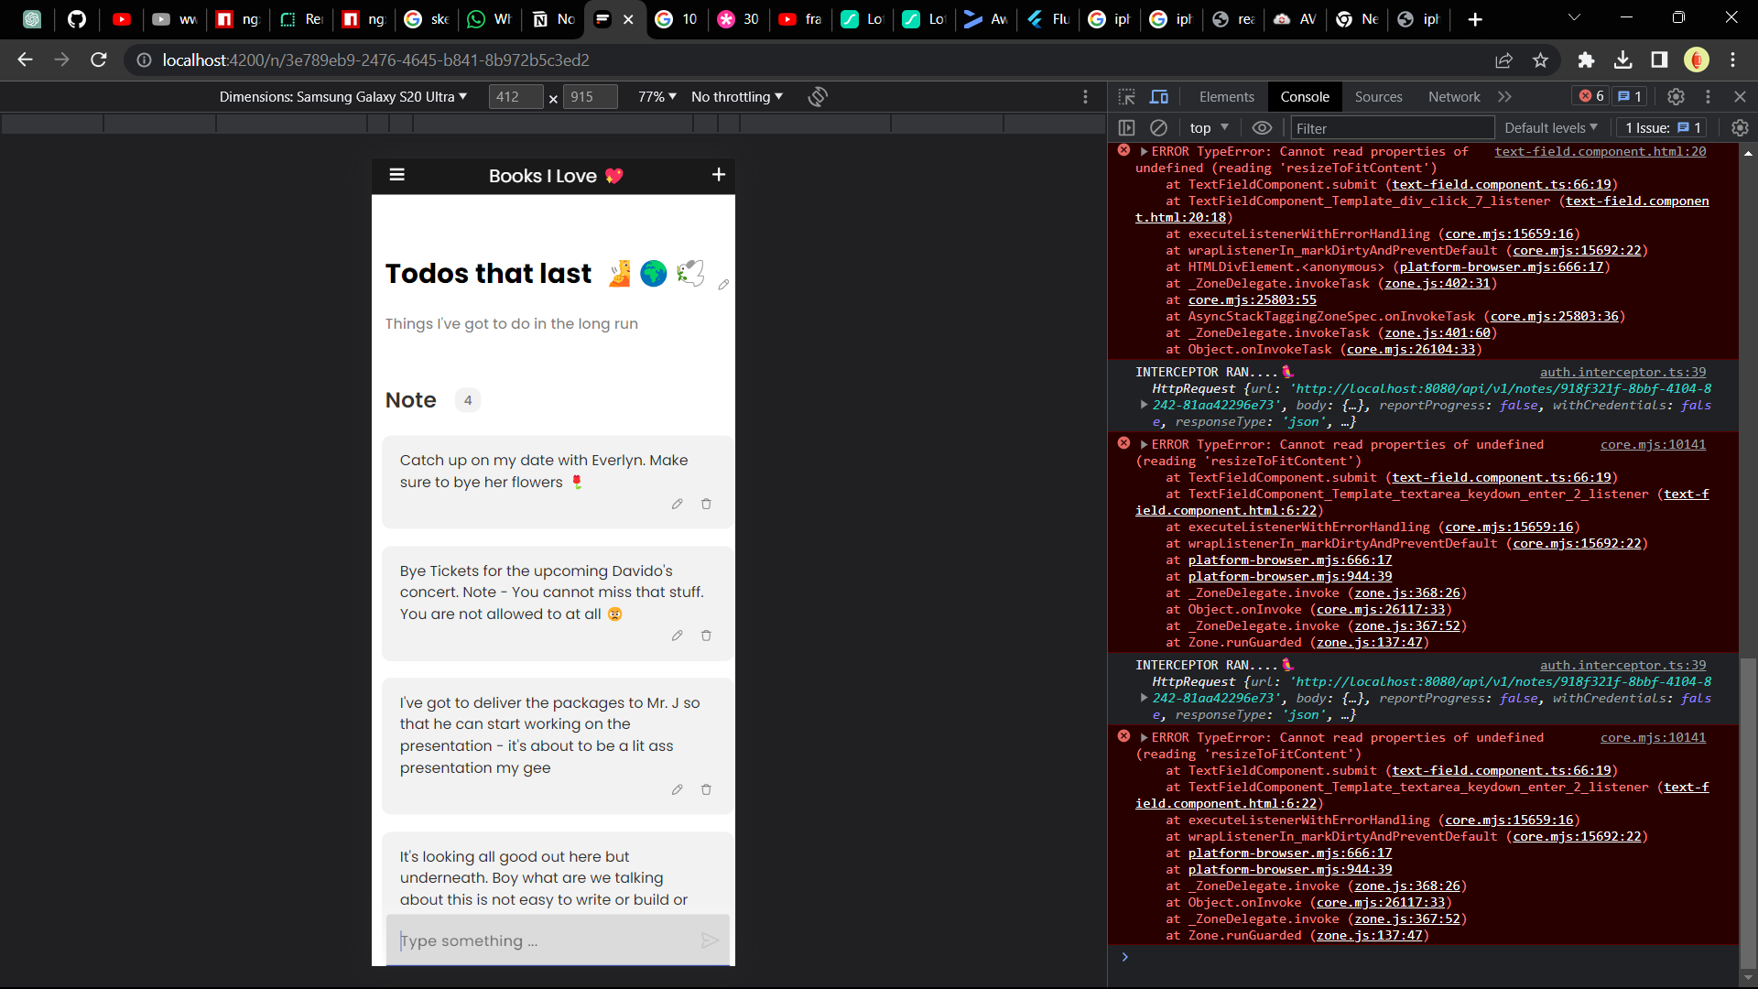

3.4 NEO CLOUD TECHNOLOGIES MOBILE APP

The first month I resumed at Neo Cloud Technologies I was tasked with building out a mobile application that helps the organization manage their Instructors and Students. I started building this application using Flutter, Node.JS, Typescript, GraphQL and MongoDB. For over 7 months I’ve been working on this application and I’m still yet to finish.

This application has a lot of features some of which are:

* Authentication & Authorization
* Roles
* Search
* User Profile
* Settings
* Faculties
* Classes
* Class Modules
* Class Schedules
* Class Instances
* Classwork’s
* Class Modules housing multiple Class Schedules
* Light and Dark Mode
* Uploading of Images
* Clean Architecture
* State Management Using Bloc
* Followed the TDD Approach to Software Development

**GitHub Link:** <https://github.com/danielchukwu/neocloud-learning-admin-mobile>

**Figma Design**

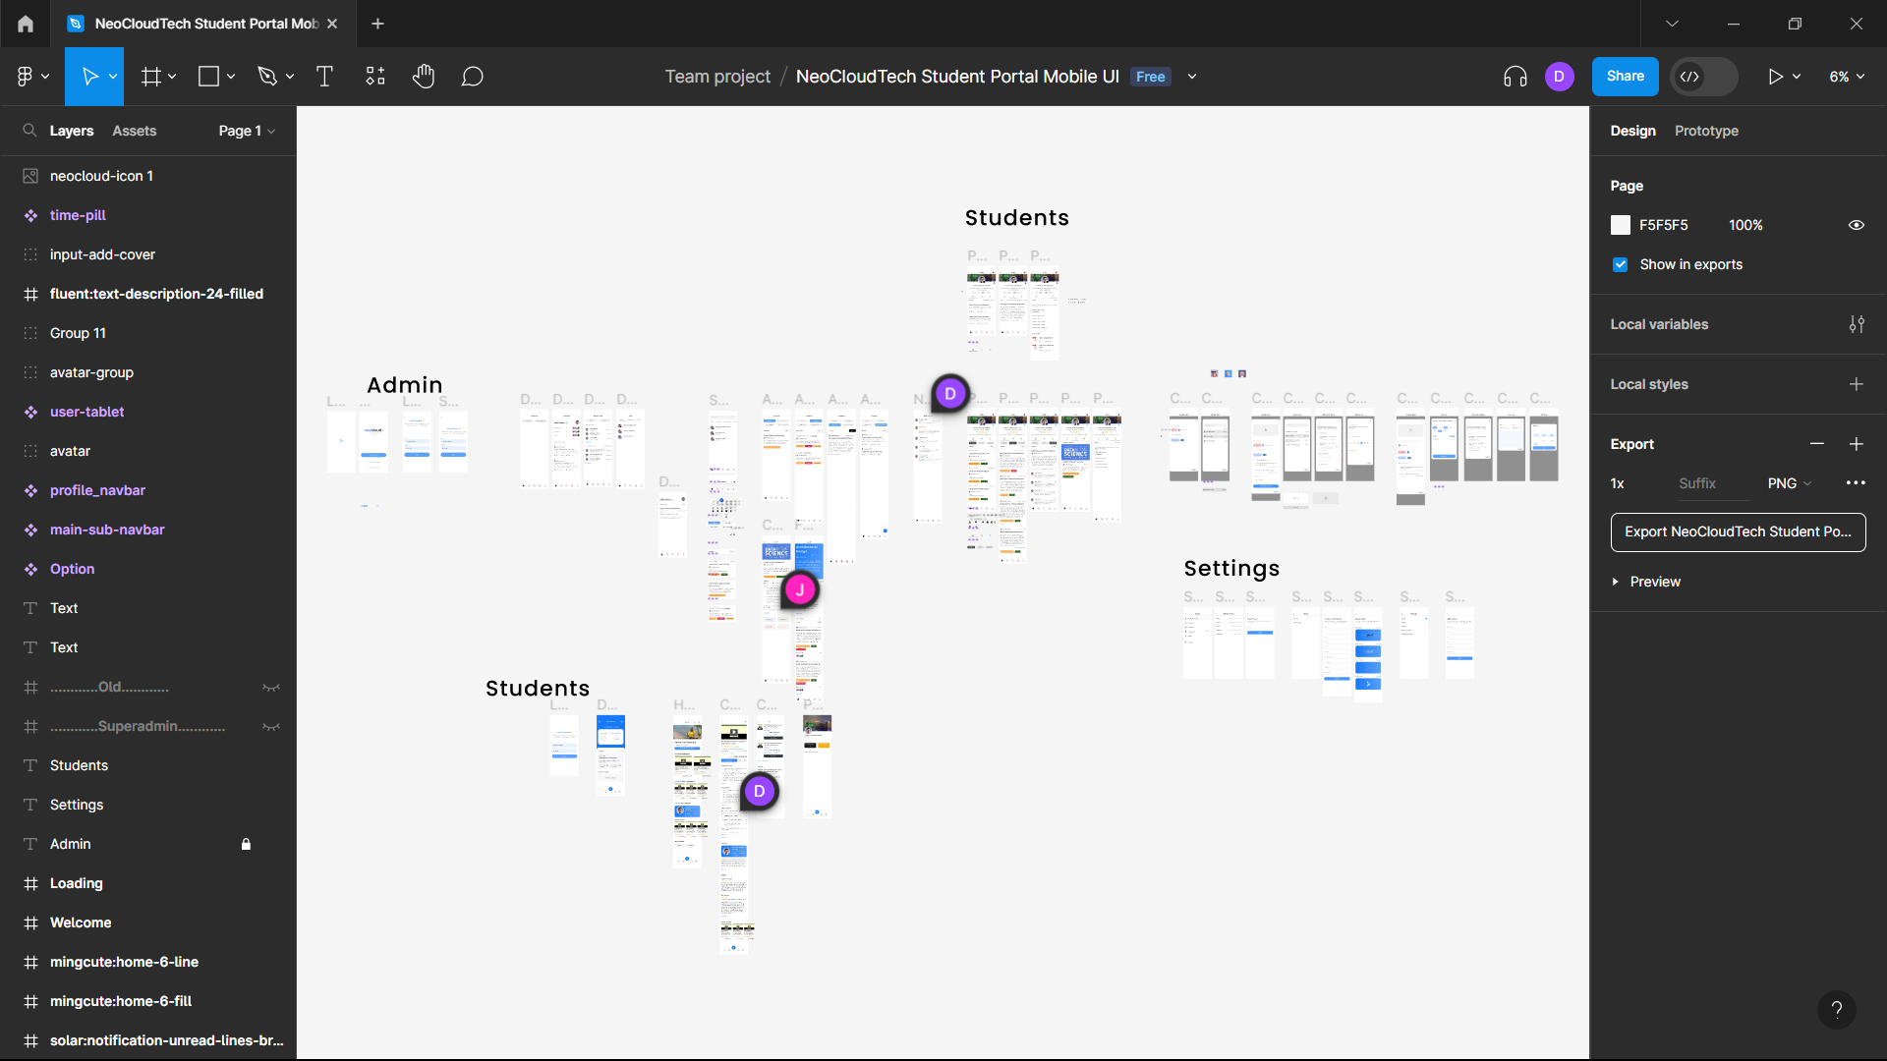

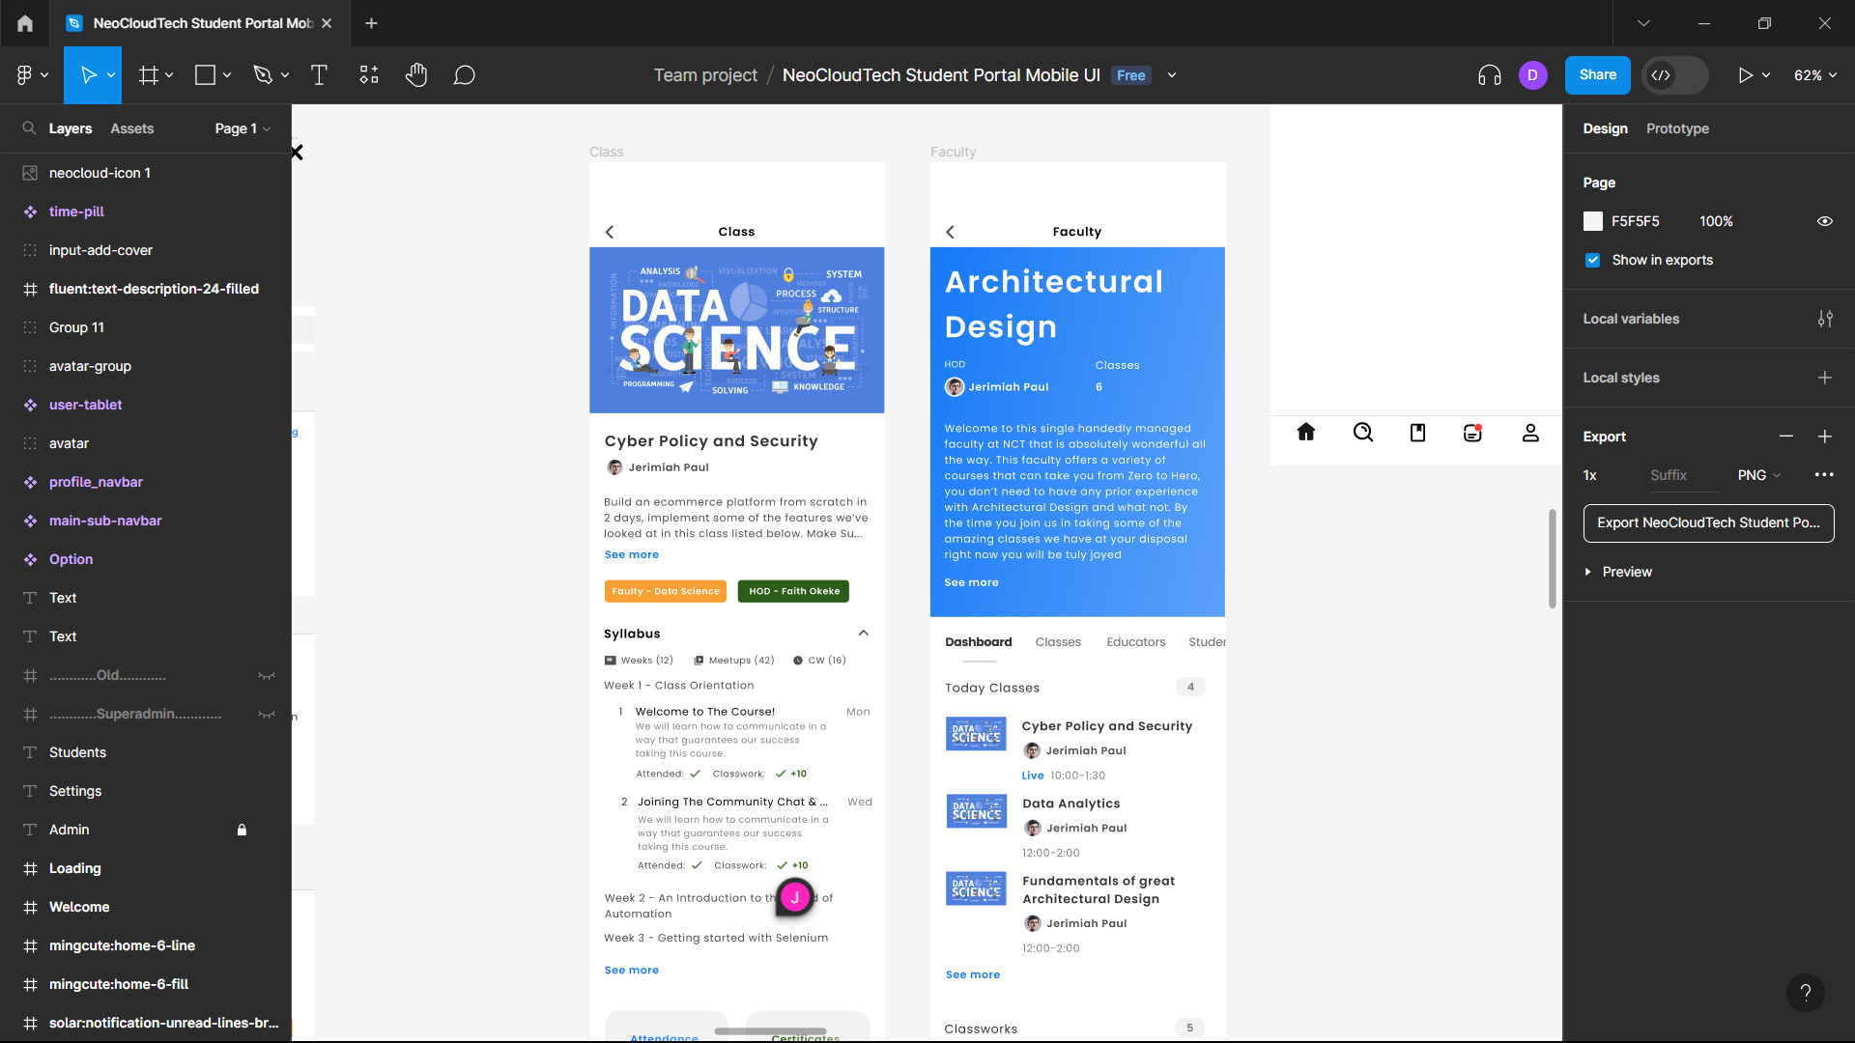

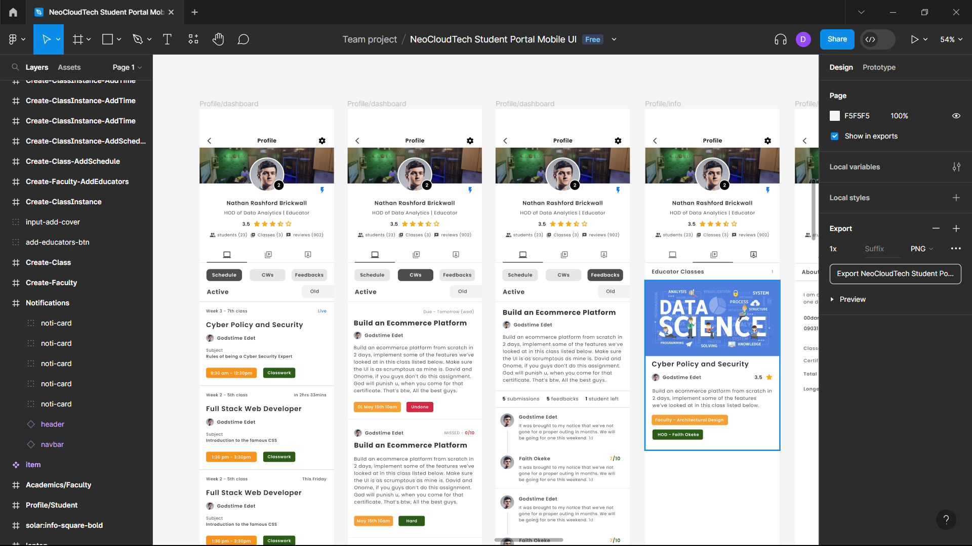

**Db Design**

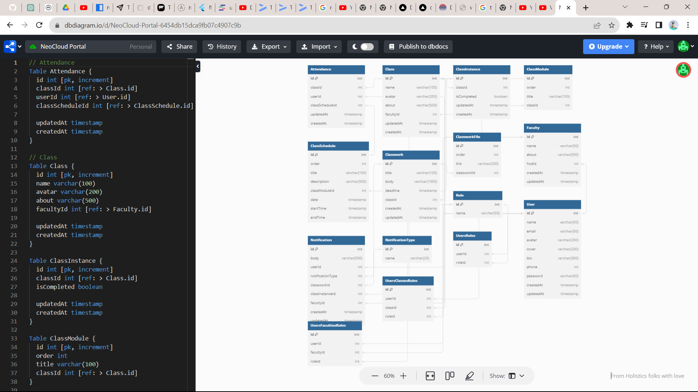

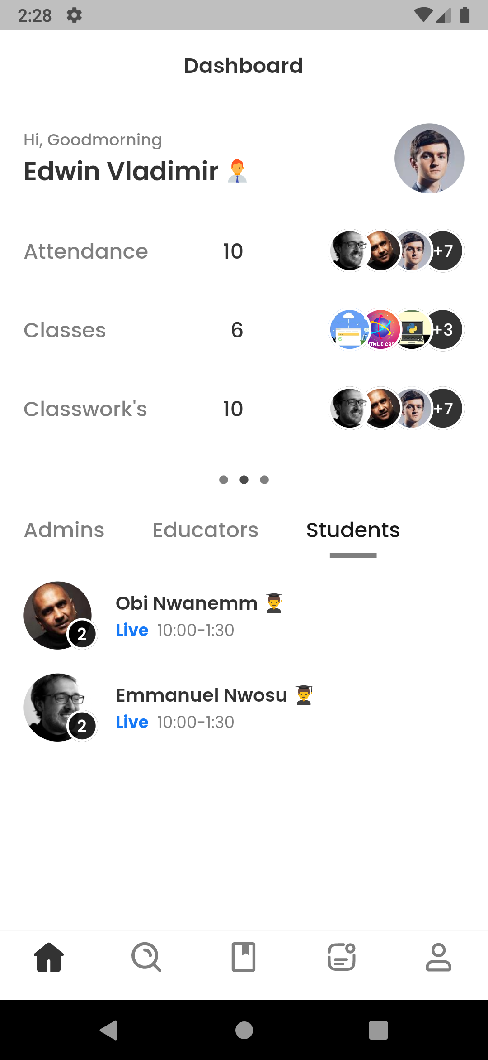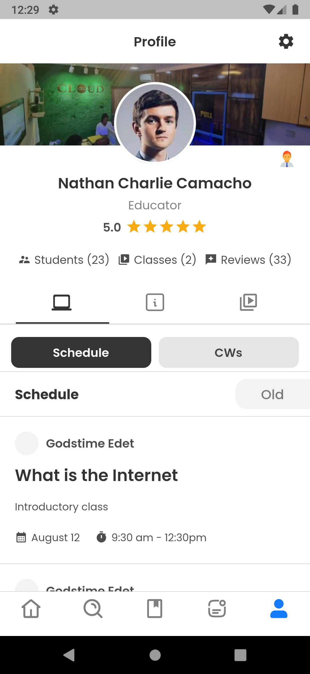

**Screenshots**

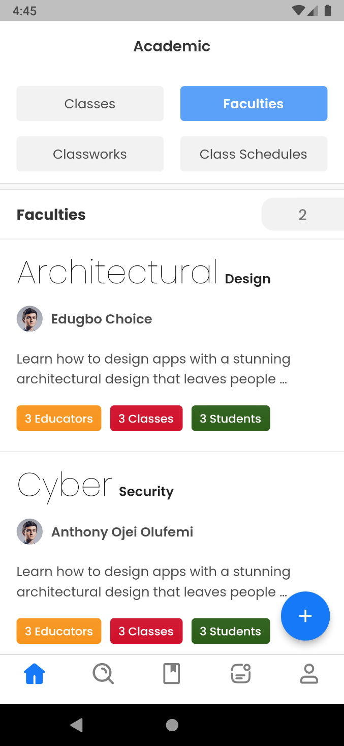

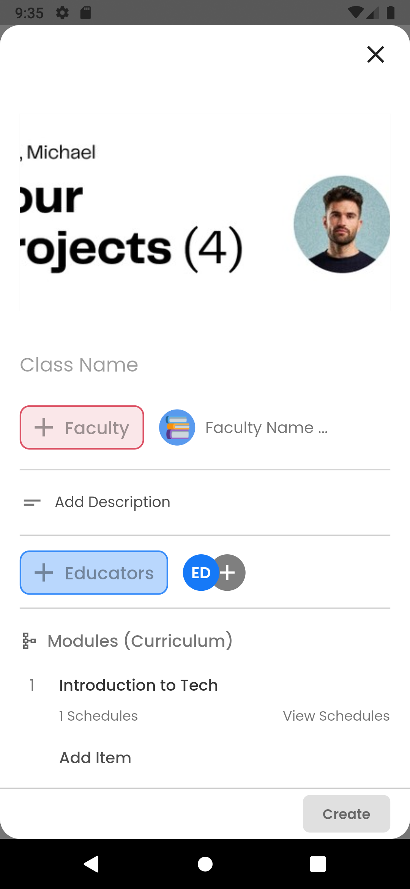

**Development Screenshot**

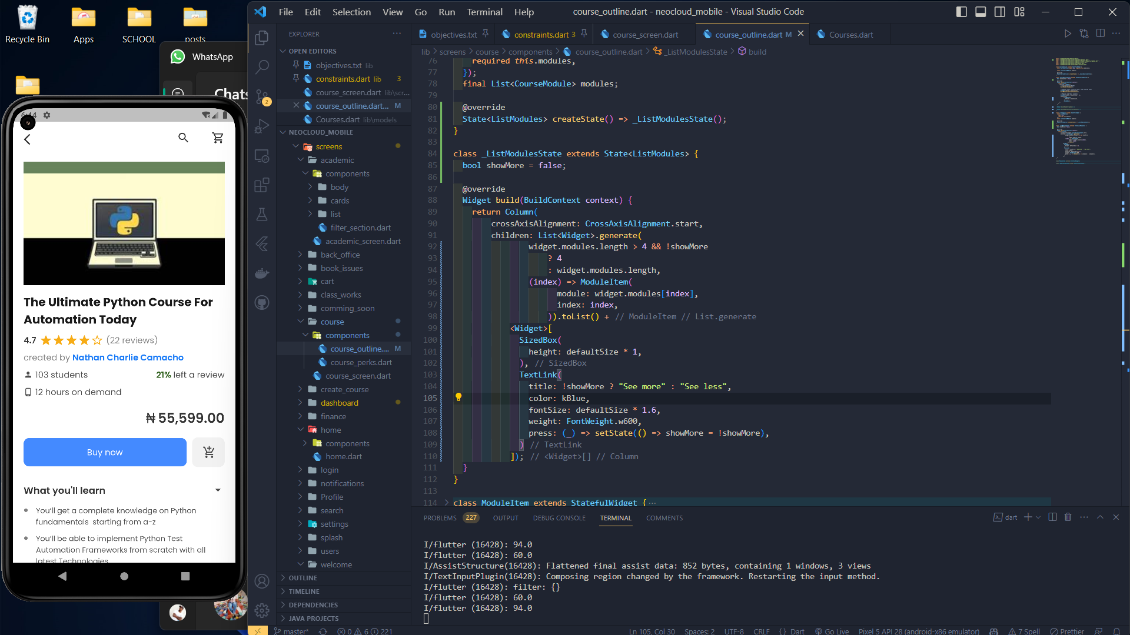

# CHAPTER FOUR

**SUMMARY, RECOMMENDATION, CONCLUSION**

4.1 SUMMARY

During my time in the program, I had the privilege of interacting with a multitude of exceptional individuals who generously shared their knowledge and provided invaluable mentorship. Their guidance played a pivotal role in shaping my understanding of the industry and allowed me to gain first-hand insights into contemporary trends and real-world operations.

These interactions not only enriched my knowledge but also provided me with a deeper appreciation of how things truly function within the field. The experience of witnessing industry professionals in action, alongside their willingness to impart their expertise, significantly accelerated my learning curve.

I am immensely grateful for the opportunity to learn from such accomplished mentors and for the exposure to the dynamic and ever-evolving landscape of the industry. Their contributions have not only broadened my horizons but have also equipped me with a practical perspective that will undoubtedly serve me well as I progress in my career.

4.2 SIWES CHALLENGES AND RECOMMENDATIONS

The Student Industrial Work Experience Scheme (SIWES) program, though highly advantageous, is not without its share of challenges. Here, I outline some of the challenges I personally observed and encountered during my seven-month internship.

**Lack of Adequate Placement Opportunities:**

* Challenge: Difficulty in securing suitable industrial placements for all students.
* Recommendation: Collaborate with more industries and organizations to expand placement options. Establish a centralized database for available placements.

**Inadequate Monitoring and Evaluation:**

* Challenge: Limited supervision and evaluation of students during their SIWES.
* Recommendation: Implement regular on-site visits and progress assessments by designated supervisors. Establish clear reporting mechanisms for both students and employers.

**Mismatch of Skills and Learning Objectives:**

* Challenge: Students may not always acquire the intended skills during their SIWES.
* Recommendation: Align the SIWES curriculum with industry demands. Regularly update learning objectives to reflect current industry trends.

**Logistical Challenges:**

* Challenge: Issues with transportation, accommodation, and safety during SIWES placements.
* Recommendation: Provide logistical support, including transportation and housing options, to ensure the safety and well-being of students.

**Mismatch of Student Skills and Employer Needs:**

* Challenge: Employers may not always find SIWES students adequately skilled.
* Recommendation: Facilitate regular communication between educational institutions and employers to ensure that students receive training aligned with industry requirements.

**Limited Post-SIWES Transition Support:**

* Challenge: Graduates may struggle to transition into full-time employment after SIWES.
* Recommendation: Establish career counseling services and job placement programs to assist SIWES graduates in finding suitable employment opportunities.

4.3 CONCLUSION

In conclusion, my experience with the Student Industrial Work Experience Scheme (SIWES) has been truly transformative and enlightening. Over the course of my internship, I had the opportunity to bridge the gap between theory and practice, gaining practical insights into my field of study that classroom learning alone could not provide.

I met inspiring mentors who not only guided me professionally but also instilled in me a passion for continuous learning. The challenges I faced during my SIWES journey served as valuable lessons, strengthening my problem-solving abilities and resilience.

Moreover, this experience has reinforced the importance of industry-academia collaboration in nurturing well-rounded and job-ready graduates. SIWES serves as a vital link between educational institutions and the professional world, preparing students for the demands of their future careers.

As I look back on my SIWES experience, I am grateful for the knowledge, skills, and network I have acquired. It has not only prepared me for the challenges of the workplace but has also ignited a lifelong commitment to growth and excellence in my chosen field. I am excited to carry these lessons forward as I embark on the next phase of my academic and professional journey

4.4 REFERENCES

1. <https://techneo.ng/knowledge-ninjas/#leadership>

2. <https://smartbukites.com/the-history-of-siwes-in-nigeria/>

3. <https://dbdiagram.io/d/NeoCloud-Portal-6454db15dca9fb07c4907c9b>

4. <https://chukwudaniel.vercel.app/>

5. <https://takenote-h0yd.onrender.com/>

6. <https://github.com/danielchukwu/neocloud-learning-admin-mobile>